**Name: Kamal Agrahari Lab: DevOps**

**ID: VU4F2223028 TE | IT |A**

Case Study: Puppet Configuration Management

# Introduction

Puppet is an open-source configuration management tool used for automating the deployment, configuration, and management of infrastructure. It enables system administrators to automate repetitive tasks, ensuring that systems maintain a desired state. Puppet is based on a client-server architecture where the Puppet Master manages the configurations of nodes (clients or agents) through a defined language. This case study explores the architecture of Puppet, its master-slave communication, core blocks, installation process, and a concluding evaluation.

# Puppet Architecture

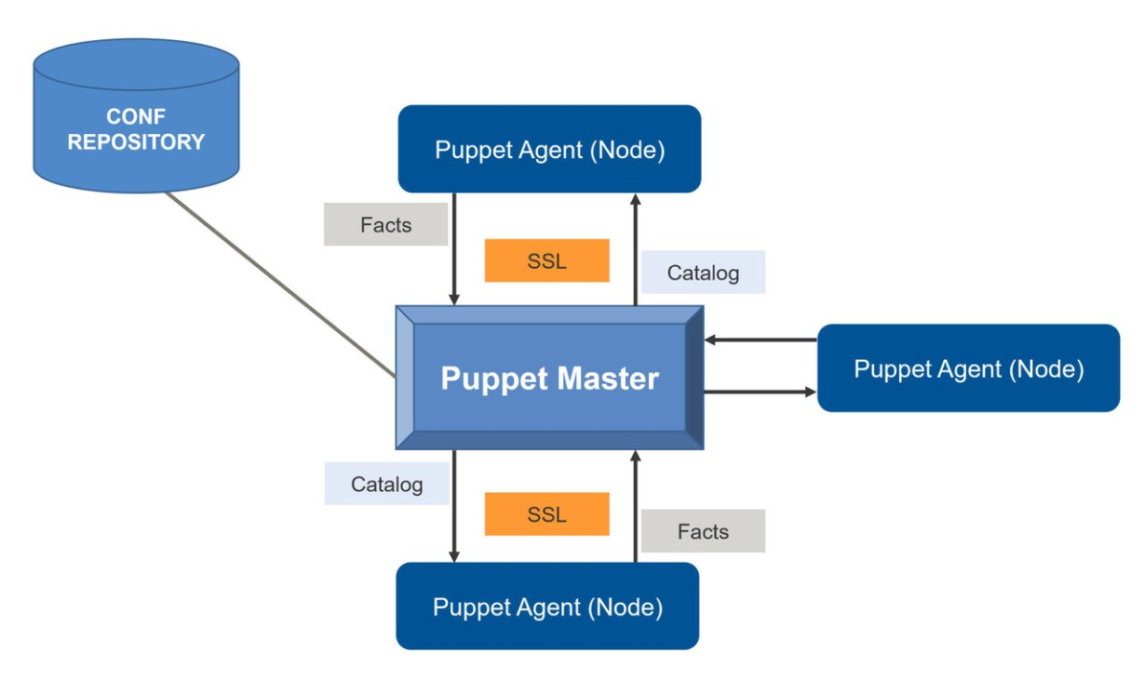

Puppet operates on a declarative, model-driven approach to automate infrastructure management. Its architecture consists of the following key components:

* Puppet Master: The Puppet Master is the central server responsible for compiling configurations into catalogs and sending them to the agents. It holds the manifest files and manages various nodes across the network.
* Puppet Agent: The Puppet Agent runs on client machines. It sends the Puppet Master facts about the system, which are pieces of information about the node's state. The agent pulls the catalog from the master and applies configurations accordingly.
* Puppet Manifests: These are files containing the desired system state written in Puppet's domain-specific language (DSL). These manifests define what configurations should be applied on the agents.
* Catalogs: Once the Puppet Master compiles the manifest for a specific agent, it creates a catalog. The catalog is a compiled version of the manifest with all variables resolved, and it is sent to the agent for execution.
* Facts and Facter: Facter is a tool that collects system information, like OS, IP address, and available memory. These 'facts' are then sent to the Puppet Master to help determine what configurations should be applied.
* PuppetDB: A database that stores configuration data, facts, reports, and catalogs, allowing Puppet to make more informed decisions during future runs.

# ii) Puppet Master-Slave Communication

Puppet follows a client-server (master-slave) architecture, and the communication between the Puppet Master and Puppet Agents follows a specific workflow:

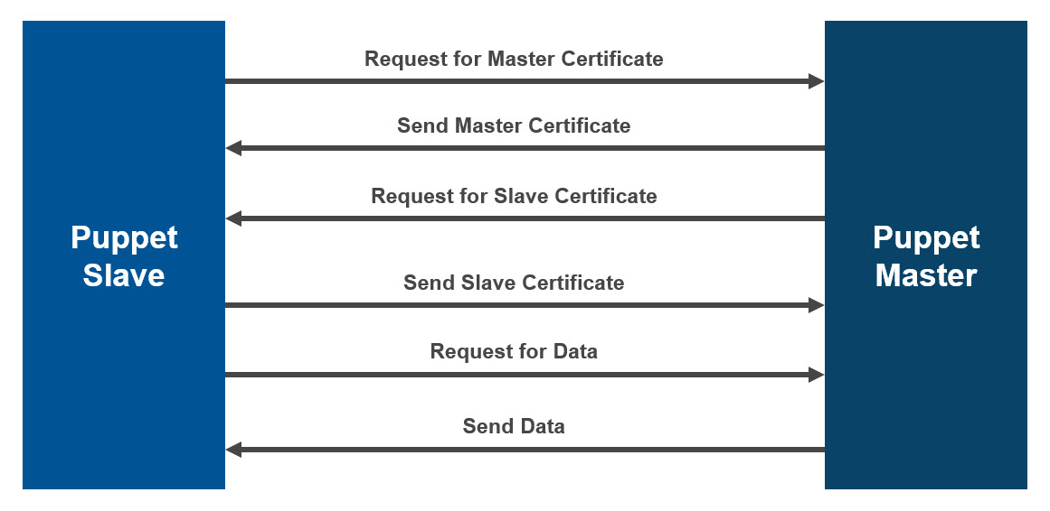

1. Node Requests Facts: The Puppet Agent sends its facts (collected by Facter) to the Puppet Master when it initiates a connection.

2. Catalog Compilation: Based on the facts sent by the agent, the Puppet Master compiles a catalog for the node, referencing the manifests, modules, and hiera data to define the desired system state.

3. Catalog Transmission: The compiled catalog is then sent back to the Puppet Agent.

4. Application of Configuration: The Puppet Agent applies the configurations based on the catalog and ensures that the system conforms to the defined state.

5. Reporting: After applying the configurations, the agent sends a report back to the Puppet Master to indicate whether the application was successful or if any errors occurred.

Puppet uses HTTPS with SSL certificates for secure communication between the master and the agents.

# iii) Puppet Blocks

Puppet uses various fundamental building blocks to define configurations, ensuring infrastructure is managed effectively:

* Resource: The core unit in Puppet. Resources represent the system's state and could be packages, files, services, etc.

Example:  
package { 'nginx':  
 ensure => 'installed',  
}

* Class: A collection of resources that define a particular system's behavior. It allows grouping of configurations and reusability.

Example:  
class webserver {  
 package { 'nginx': ensure => 'installed', }  
 service { 'nginx': ensure => 'running', }  
}

* Node Definition: Nodes allow you to specify different configurations for different hosts.

Example:  
node 'webserver1.example.com' {  
 include webserver  
}

* Module: A module is a collection of manifests, templates, and files that are structured to support code reuse and organization.
* Templates: These are dynamic files used in configuration management, allowing variables to be inserted into configuration files.
* Hiera: A key/value lookup tool for configuration data, which allows separating code from data. This makes it easier to manage multiple configurations for different environments.

# iv) Installation and Configuring Puppet Master and Agent

## Installing Puppet Master on a Linux Machine (Ubuntu)

1. Install Puppet Master:

sudo apt update  
sudo apt install puppetmaster

2. Configure Puppet Master:

sudo nano /etc/puppet/puppet.conf  
Set up your environment and module path within the puppet.conf file:  
[master]  
environmentpath = $confdir/environments  
basemodulepath = $confdir/modules

3. Start the Puppet Master service:

sudo systemctl start puppetmaster  
sudo systemctl enable puppetmaster

## Installing Puppet Agent

1. Install Puppet Agent:

sudo apt install puppet-agent

2. Configure Puppet Agent:

Update the /etc/puppet/puppet.conf file to point to the Puppet Master:  
[agent]  
server = puppetmaster.example.com

3. Start the Puppet Agent:

sudo systemctl start puppet  
sudo systemctl enable puppet

## Signing the SSL Certificates

1. On the Puppet Master: Check for incoming certificate requests:

sudo puppet cert list

2. Sign the certificate request:

sudo puppet cert sign <agent-node-name>

3. On the Puppet Agent: After signing, the agent can initiate communication:

sudo puppet agent --test

# v) Conclusion

Puppet is a powerful tool for automating and managing infrastructure at scale. Its architecture, built around the master-agent model, ensures that systems across the network are always configured according to the desired state. The block-based system, involving resources, classes, and modules, allows administrators to manage configurations in an efficient and modular way. By automating repetitive tasks and ensuring consistency across systems, Puppet helps improve system reliability and efficiency in DevOps practices.  
This case study illustrates how Puppet simplifies system administration tasks, enabling organizations to adopt more scalable and efficient infrastructure management processses.